SWT 12031: Practical for Object oriented Program
Department of Information and Communication Technology
Faculty of Technology
Java Basics

Labsheet 02

Reg. Number: SEU/IS/20/ICT/084
Academic Year :2020/2021
Date: 2023.01.24
Practical No : 02

Title: Java Basics

Aims:
- Practice with Java Basics programming Language environment preparation

Tasks 01:

Java User Input String

import java.util.Scanner;
class Main {
public static void main(String[] args) {
Scanner myObj = new Scanner(System.in);
String userName;
System.out.print("Enter username :");
userName = myObj.nextLine();
System.out.println("Username is: " + userName);
}
}
Output:
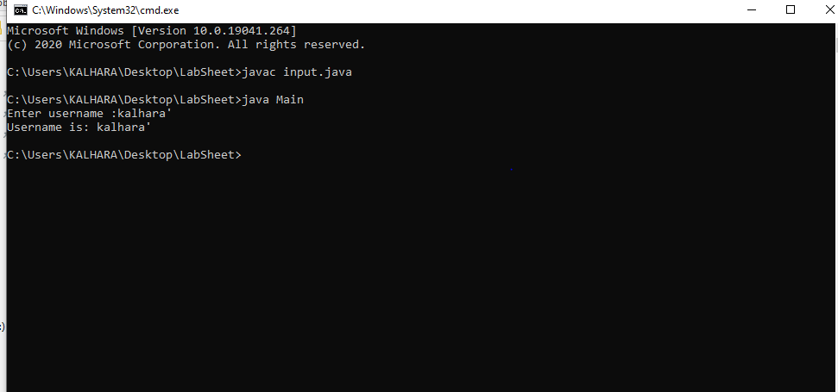

Tasks 02:

Java Output / Print Text

public class output {
public static void main(String[] args) {
System.out.println("Hello World!");
System.out.println("I am learning Java.");
System.out.println("It is awesome!");
}
}

Output:
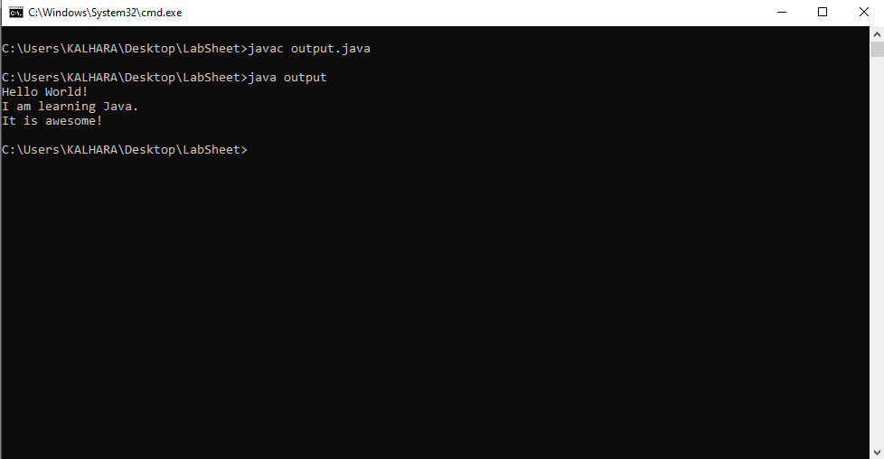

Tasks 03:
Java Output Numbers
public class Main {
public static void main(String[] args) {
System.out.println(3);
System.out.println(358);
System.out.println(50000);
}
}
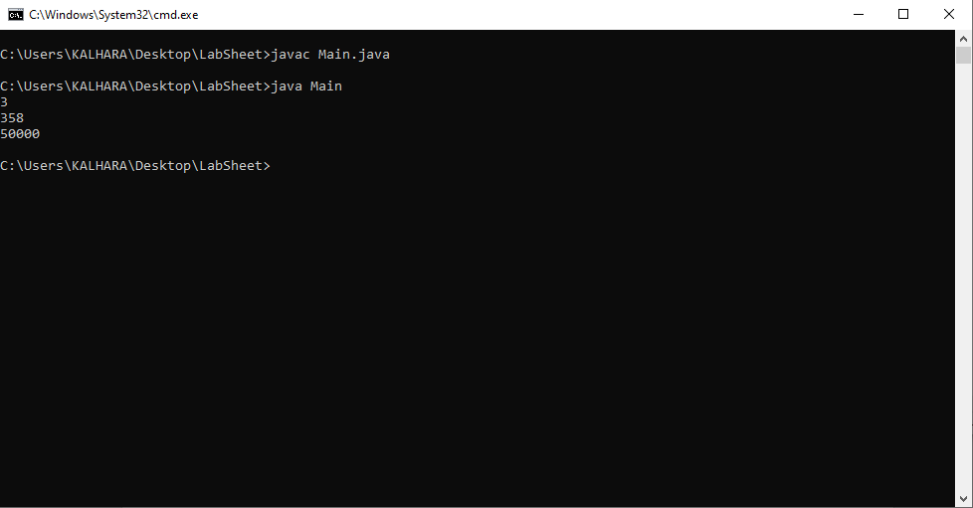
Output:

Tasks 04:
Java Comments
01.Single-line Comments
public class Main {
public static void main(String[] args) {
// This is a comment
System.out.println("Hello World");// This is a comment
}
}
Output:
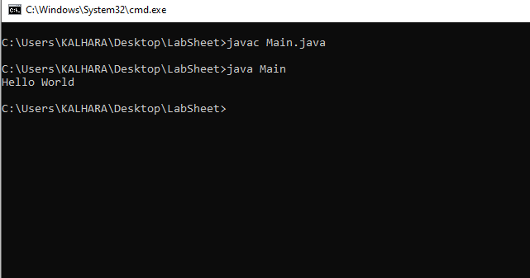

02. Java Multi-line Comments
public class Main {
public static void main(String[] args) {
/* The code below will print the words Hello World
to the screen, and it is amazing */
System.out.println("Hello World");
}
}
Output:

Tasks 05:
Java Variables String
public class Main {
public static void main(String[] args) {
String name = "John";
System.out.println(name);
}
}
Output:
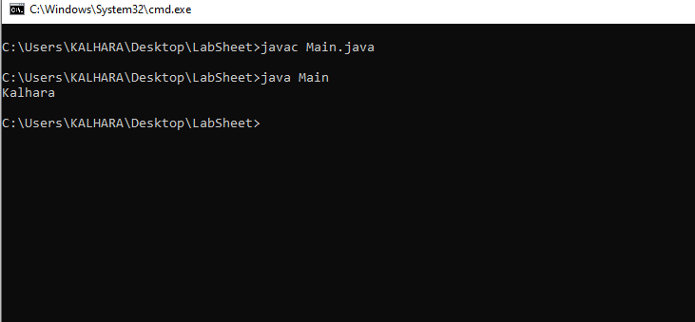

Tasks 06:
Java Variables Numbers
public class Main {
public static void main(String[] args) {
int myNum;
myNum = 10;
System.out.println(myNum);
}
}

Output:

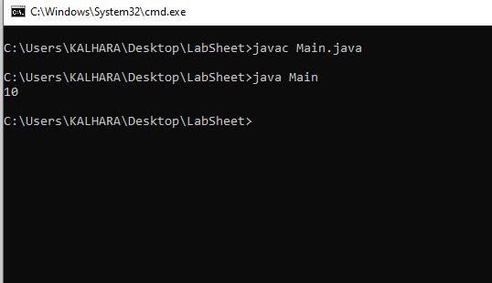

Tasks 07:
Java Variables Multiple Numbers
public class Main {
public static void main(String[] args) {
int myNum = 15;
myNum = 20; // myNum is now 20
System.out.println(myNum);
}
}
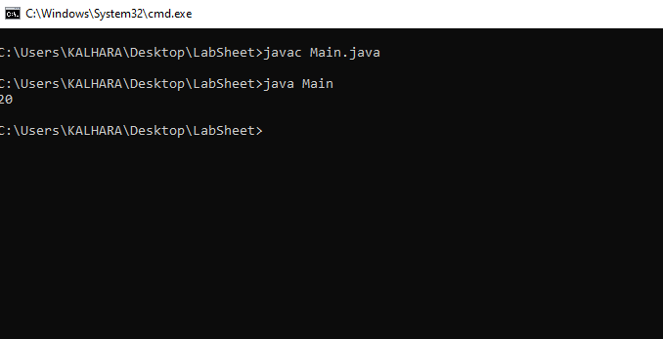
Output:

Tasks 08:
Display Variables
public class Main {
public static void main(String[] args) {
String firstName = "John ";
String lastName = "Doe";
String fullName = firstName + lastName;
System.out.println(fullName);
}
}
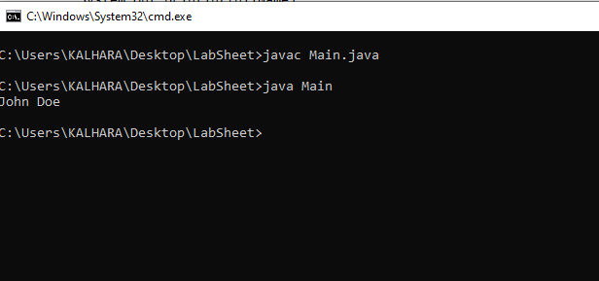
Output:

public class Main {
public static void main(String[] args) {
int x = 5;
int y = 6;
System.out.println(x + y);
}
}

Output:
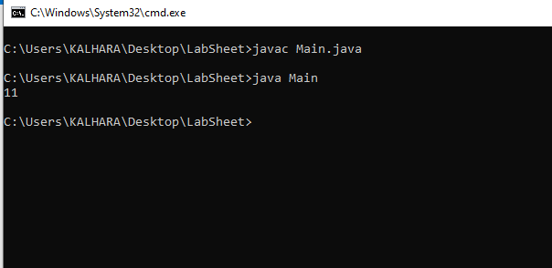
Tasks 09:
Declare Many Variables
public class Main {
public static void main(String[] args) {
int x = 5, y = 6, z = 50;
System.out.println(x + y + z);
}
}

Output:
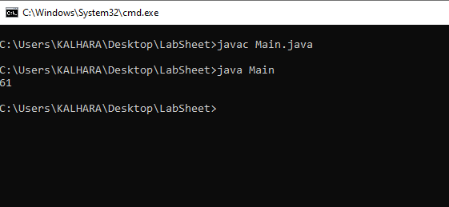
Tasks 10:
Boolean Types
public class Main {
public static void main(String[] args) {
boolean isJavaFun = true;
boolean isFishTasty = false;
System.out.println(isJavaFun);
System.out.println(isFishTasty);
}
}

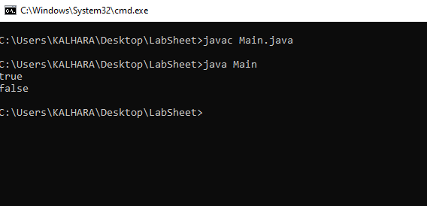
Output:

Tasks 11:
Java Characters
public class Main {
public static void main(String[] args) {
char myVar1 = 65, myVar2 = 66, myVar3 = 67;
System.out.println(myVar1);
System.out.println(myVar2);
System.out.println(myVar3);
}
}

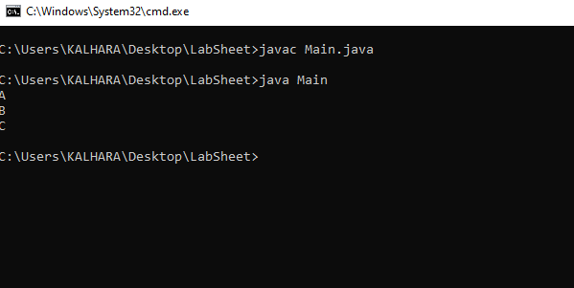
Output:

Tasks 12:
Java Operators
public class Main {
public static void main(String[] args) {
int sum1 = 100 + 50;
int sum2 = sum1 + 250;
int sum3 = sum2 + sum2;
System.out.println(sum1);
System.out.println(sum2);
System.out.println(sum3);
}
}
Output:
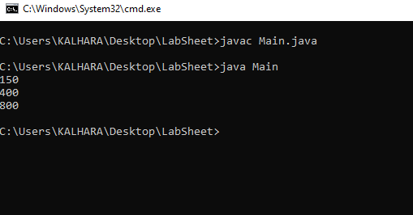
01.Arithmetic Operators
public class Main {
public static void main(String[] args) {
int x = 5;
int y = 3;
System.out.println(x * y);
}
}
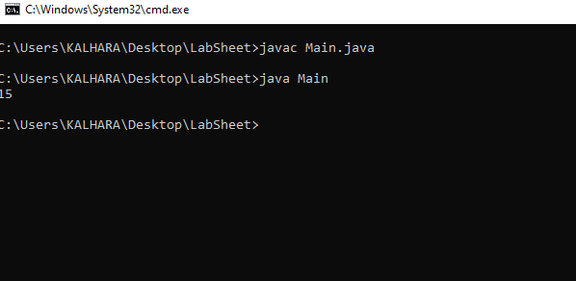
Output:

02.Comparison Operators
public class Main {
public static void main(String[] args) {
int x = 5;
int y = 3;
System.out.println(x > y); // returns true, because 5 is higher than 3
}
}
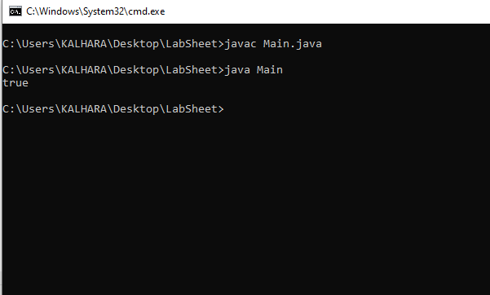
Output:

03.Logical Operators
public class Main {
public static void main(String[] args) {
int x = 5;
System.out.println(x > 3 && x < 10);
}
}
Output:
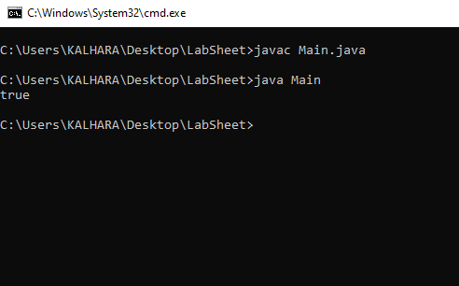

Tasks 13:
Java Strings
01.String Length
public class Main {
public static void main(String[] args) {
String txt = "ABCDEFGHIJKLMNOPQRSTUVWXYZ";
System.out.println("The length of the txt string is: " + txt.length());
}
}

Output:
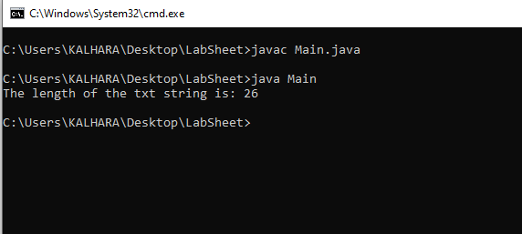
02.String Methods
public class Main {
public static void main(String[] args) {
String txt = "Hello World";
System.out.println(txt.toUpperCase());
System.out.println(txt.toLowerCase());
}
}
Output:

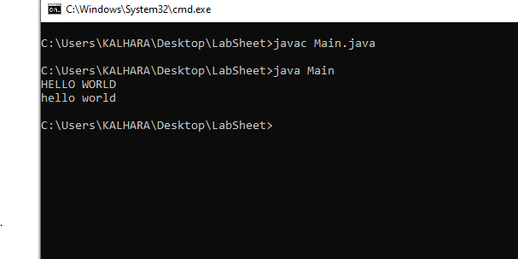

Tasks 14:
Java Math
public class Main {
public static void main(String[] args) {
System.out.println(Math.max(5, 10));
}
}
Output:
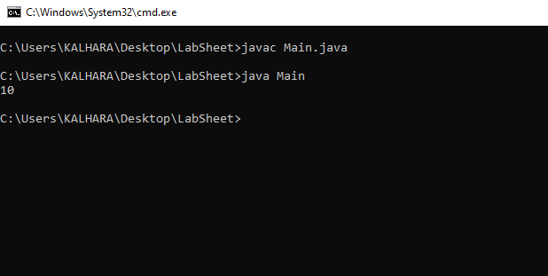
Tasks 15:
Java Conditions and If Statements
01.if Statement
public class Main {
public static void main(String[] args) {
int x = 20;
int y = 18;
if (x > y) {
System.out.println("x is greater than y");
}
}
}

Output:
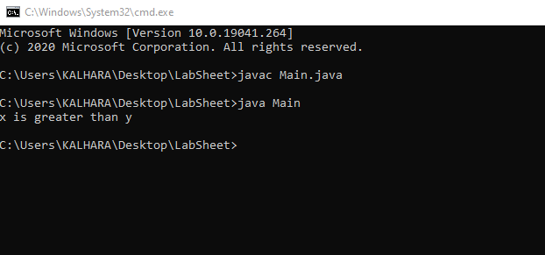
02.else Statement
public class Main {
public static void main(String[] args) {
int time = 20;
if (time < 18) {
System.out.println("Good day.");
}
else {
System.out.println("Good evening.");
}
}
}
Output:
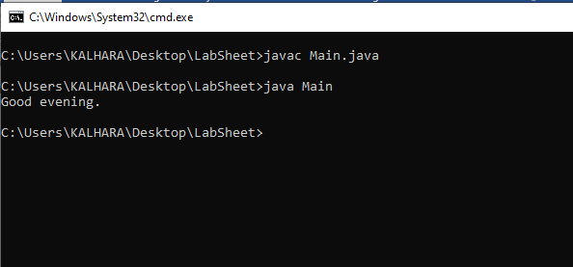

03.else if Statement
public class Main {
public static void main(String[] args) {
int time = 22;
if (time < 10) {
System.out.println("Good morning.");
}
else if (time < 18) {
System.out.println("Good day.");
}
else{
System.out.println("Good evening.");
}
}
}
Output:
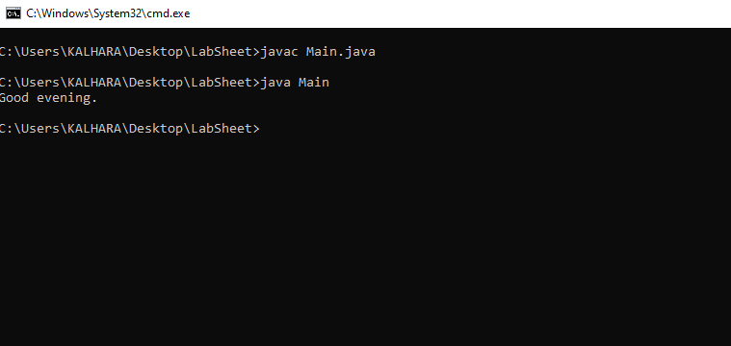

03.If...Else
public class Main {
public static void main(String[] args) {
int time = 20;
if (time < 18) {
System.out.println("Good day.");
}
else {
System.out.println("Good evening.");
}
}
}
Output:
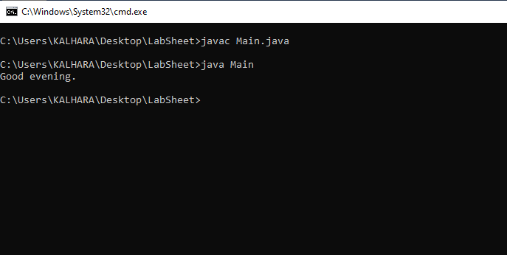

Tasks 16:
Java Switch Statements
public class Main {
public static void main(String[] args) {
int day = 4;
switch (day) {
case 1:
System.out.println("Monday");
break;
case 2:
System.out.println("Tuesday");
break;
case 3:
System.out.println("Wednesday");
break;
case 4:
System.out.println("Thursday");
break;
case 7:
System.out.println("Sunday");
break;
}
}
}
Output :
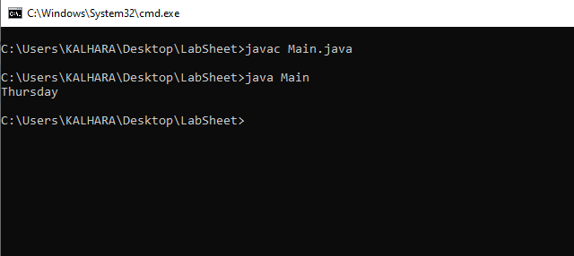

Tasks 17:
default Keyword
public class Main {
public static void main(String[] args) {
int day = 4;
switch (day) {
case 6:
System.out.println("Today is Saturday");
break;
case 7:
System.out.println("Today is Sunday");
break;
default:
System.out.println("Looking forward to the Weekend");
}
}
}
Output:
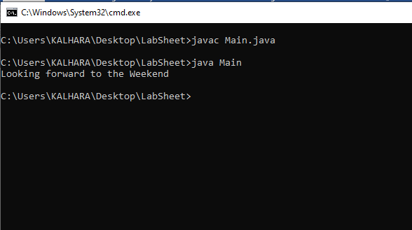

Tasks 18:
Java Loops
01. Java While Loop
public class Main {
public static void main(String[] args) {
int i = 0;
while (i < 5) {
System.out.println(i);
i++;
}
}
}
Output:
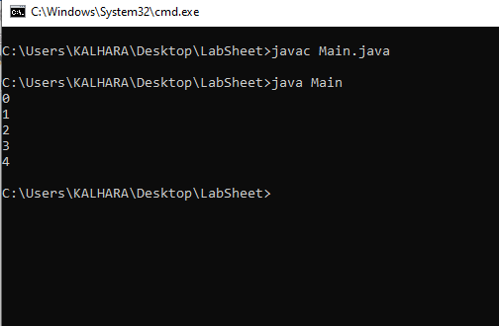

02.Java Do/While Loop
public class Main {
public static void main(String[] args) {
int i = 0;
do {
System.out.println(i);
i++;
}
while (i < 5);
}
}

Output:
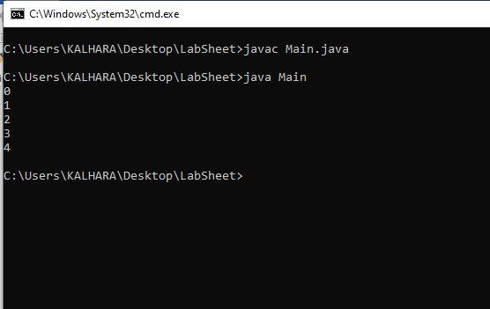
03.Java For Loop
public class Main {
public static void main(String[] args) {
for (int i = 0; i < 5; i++) {
System.out.println(i);
}
}
}
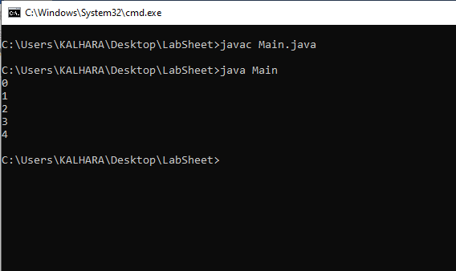
Output:

04.Nested Loops
public class Main {
public static void main(String[] args) {
for (int i = 1; i <= 2; i++) {
System.out.println("Outer: " + i);
for (int j = 1; j <= 3; j++) {
System.out.println(" Inner: " + j);
}
}
}
}
Output:
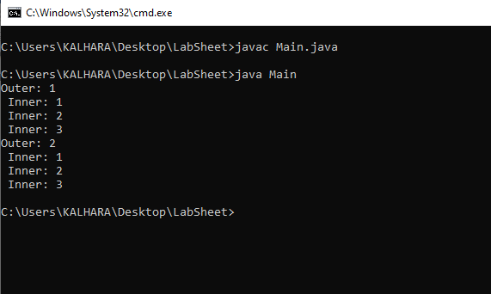
05.For-Each Loop
public class Main {
public static void main(String[] args) {
String[] cars = {"Volvo", "BMW", "Ford", "Mazda"};
for (String i : cars) {
System.out.println(i);
}
}
}

Output:
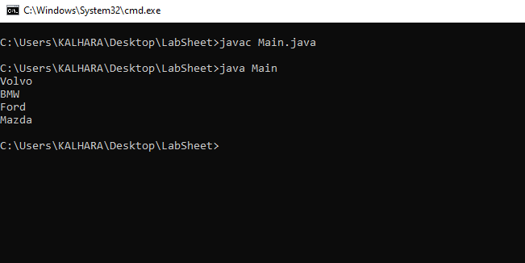

Tasks 19:
Java Break and Continue
01.Java Break
public class Main {
public static void main(String[] args) {
for (int i = 0; i < 10; i++) {
if (i == 4) {
break;
}
System.out.println(i);
}
}
}
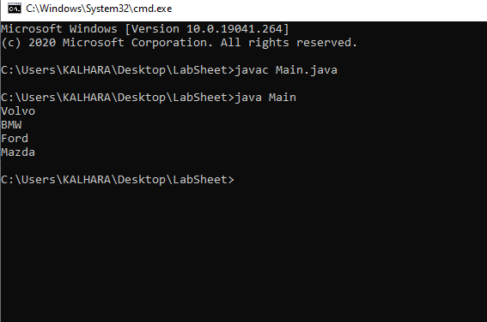
Output:
0.Java Continue
public class Main {
public static void main(String[] args) {
for (int i = 0; i < 10; i++) {
if (i == 4) {
continue;
}
System.out.println(i);
}
}
}
Output:
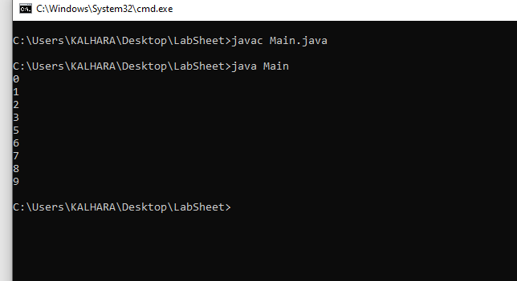

Tasks 20:
Java Arrays
public class Main {
public static void main(String[] args) {
String[] cars = {"Volvo", "BMW", "Ford", "Mazda"};
System.out.println(cars[0]);
}
}

Output:
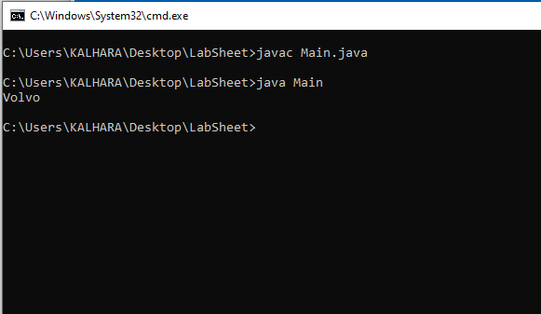
01.Change an Array Element
public class Main {
public static void main(String[] args) {
String[] cars = {"Volvo", "BMW", "Ford", "Mazda"};
cars[0] = "Opel";
System.out.println(cars[0]);
}
}
Output:
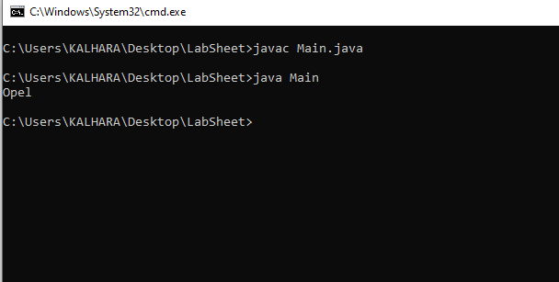
02.Array Length
public class Main {
public static void main(String[] args) {
String[] cars = {"Volvo", "BMW", "Ford", "Mazda"};
System.out.println(cars.length);
}
}
Output:
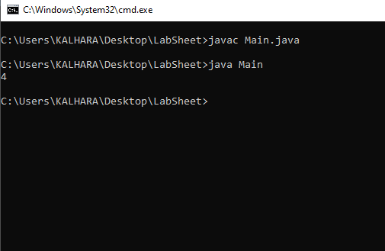
03.Loop Through an Array
public class Main {
public static void main(String[] args) {
String[] cars = {"Volvo", "BMW", "Ford", "Mazda"};
for (int i = 0; i < cars.length; i++) {
System.out.println(cars[i]);
}
}
}

Output:
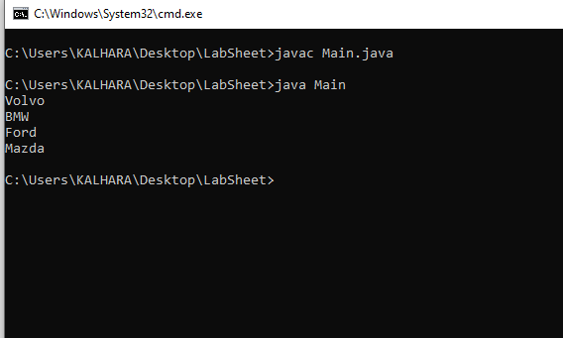
04.Multidimensional Arrays
public class Main {
public static void main(String[] args) {
int[][] myNumbers = { {1, 2, 3, 4}, {5, 6, 7} };
System.out.println(myNumbers[1][2]);
}
}
Output:
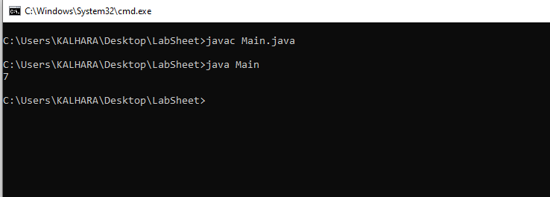

05.Loop Through a Multi-Dimensional Array
public class Main {
public static void main(String[] args) {
int[][] myNumbers = { {1, 2, 3, 4}, {5, 6, 7} };
for (int i = 0; i < myNumbers.length; ++i) {
for(int j = 0; j < myNumbers[i].length; ++j) {
System.out.println(myNumbers[i][j]);
}
}
}
}
Output:
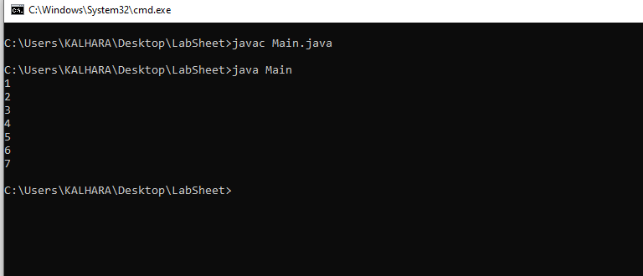

Exercise 01:
- Create your first java program that will print, “Hello, Welcome to Object Oriented Programming!”.

  - Make the name of the class as ‘HelloWorld’.
  - Write the main method that will execute the print statement given.
  - Save the program by giving the file name same as class class and with the .java extension.
  - Compile the program you created.
  - Execute the program you created.
public class HelloWorld{
public static void main (String[] args){
System.out.println("Hello World");
}

}

Output:

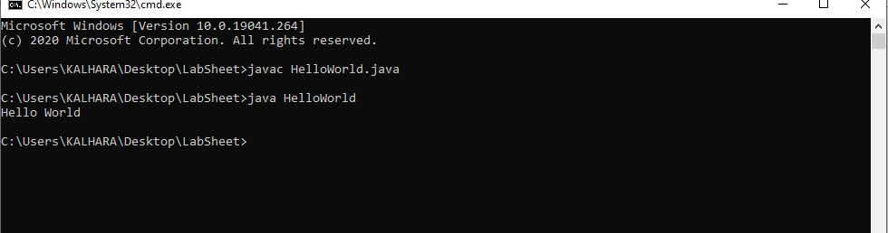

2. Create a class to display the following.
Name : Sam
Subject: OOP
Duration : 4 Months
Grade : A+

public class Exercise1{
public static void main(String[] args){

String Name="Sam";
String Subject ="OOP";
String Duration ="4 Months";
String Grade="A+";

System.out.println(" Name :"+ Name);
System.out.println(" Subject:"+ Subject);
System.out.println(" Duration:"+Duration);
System.out.println(" Grade :"+ Grade);

}

}

Output:
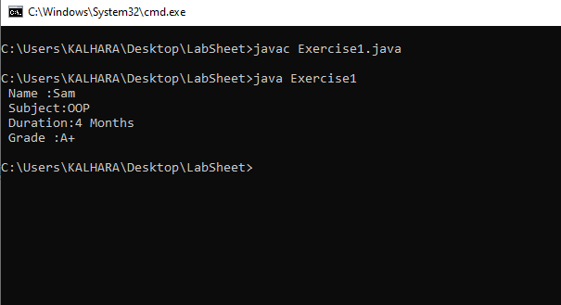
Exercise 02:

  - 1. Create a class called Student. Within this class,
  - a. Define two variables namely id and name.
b. Initialize id to 1 and name to Kamal.
c. Display everything inside the Method.

public class Students{
public static void main (String[] args){
int id=1;
String Name ="Kamal";
System.out.println("Id :"+id);
System.out.println("Name:"+Name);

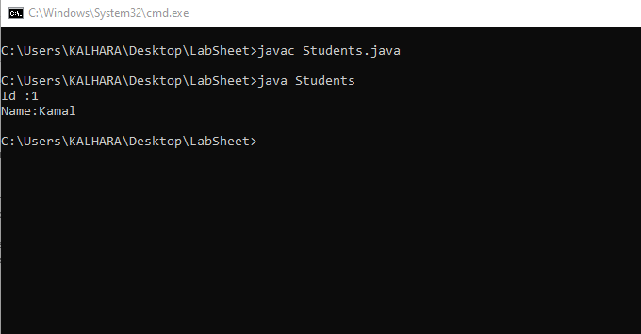
}
}

Exercise 03:

  - 1. Create a class called Employee. Within the class,
    - a. Create the variables empid, name and salary (salary is a float value).
    - b. Assign the Value for those variable and display all.
    - c. Change the Value after display those value with the same method.

import java.util.Scanner;

public class Employee{
public static void main(String []args){
String empid_name;
float salary;
Scanner scanner = new Scanner(System.in);

System.out.print("Enter empid name:");
empid_name =scanner.nextLine();

System.out.print("Enter salary:");
salary=scanner.nextFloat();

System.out.print("empid name is a:"+empid_name);
System.out.print("salary is a:"+salary);
}
}

Output:
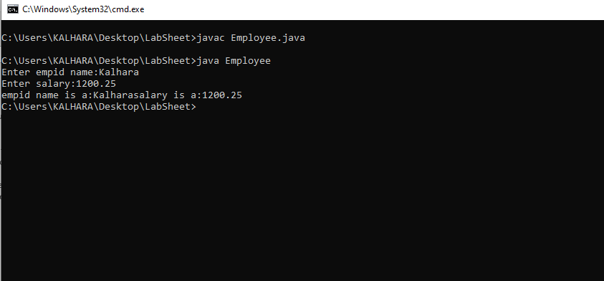
Exercise 04:

1. Create a class called MyName to print your name.

public class MyName{
public static void main(String []args){
System.out.println("My name is Kalhara");
}
}
Output:
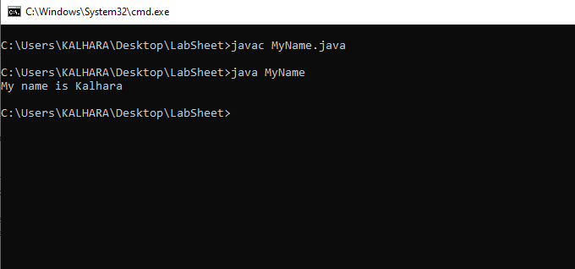

2. Create a class to display the following

Java is an example for OOP
It is a pure Object Oriented language

public class MyClass{
public static void main(String[] args){
System.out.println("Java is an example for OOP ");
System.out.println("It is a pure Object Oriented language");
}
}

Output:
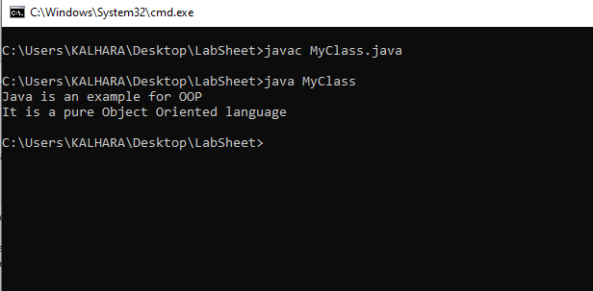

3.
  - • Create a class called Rectangle. Within the class,
    - I. Create the variables length and width.
    - II. Assign the Value for those variable (float data type).
    - III. Next, creae another method calculateArea() to calculate the area of the given rectangle.

import java.util.Scanner;
public class Rectangle{
public static void main (String []args){

Scanner sc =new Scanner(System.in);

float length;
float width;
System.out.print("Enter Length:");
length = sc.nextFloat();
System.out.print("Enter Width:");
width = sc.nextFloat();
float Area;
Area =length*width;
System.out.println("Area is:"+Area);
}
}

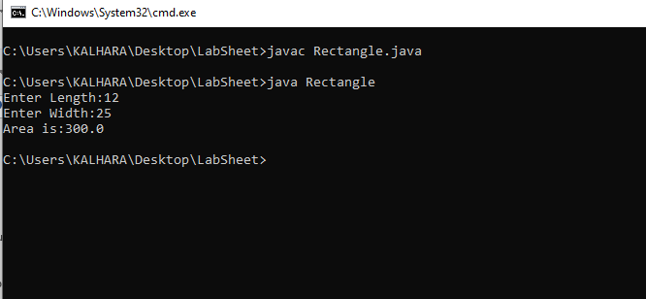
Output:

Discussion :
• User Input
• Output
• Comments
• Operators
• Conditional Statement
• Loops
• Array

